A Mini Project Report on

**ENGINEERING MECHANICS**

*Submitted in partial fulfilment of the requirement for the Degree of*

**B. Tech.**

in

**Computer Science and Technology**

*Submitted By:*

**Members of Group 22, CSE ‘K’**

**Prottay Kumar Adhikary : 1912157**

**Saurabh Sinha : 1912159**

**Subhojit Ghimire : 1912160**

*Under the guidance of:*

**Dr. Simanchal Kar**

**Assistant Professor**

**Department of Mechanical Engineering**

**NIT Silchar**

10th July, 2020

ME 101

Engineering Mechanics

1912157, 1912159, 1912160

CSE

2nd

July 2020

**Semester_______ Branch__________Regn. No_______________________**

**Subject_____________________________ Subject Code_______________**

**Date of Submission _____________________________________________**

**END SEMESTER MINI PROJECT ______________________________________**

**NATIONAL INSTITUTE OF TECHNOLOGY, SILCHAR**



**Group I**

**1.**

**i) Ans) [Plane Truss]** plane truss

**ii) Ans) [Kinetics of Particles]** Kinetics

**iii) Ans) [Wedge Friction]** perpendicular

**iv) Ans) [Theorem of Pappus-Guldin]** surface area and the volume of the revolving body.

**v) Ans) [Statics of Rigid Body]** constant

**vi) Ans) [Kinetics of Particles]** Rectilinear motion

**vii) Ans) [Principle of Work and Energy]** conservative force

**viii) Ans) [Principle of Impulse and Momentum]** inertia and angular speed

**ix) Ans) [Static Equilibrium]** Lami’s theorem

**x) Ans) [Varignon’s Theorem]** Varignon’s theorem

**2.**

**i) Ans) [Simple Screw Jack]** True.

**ii) Ans) [Belt Friction]** False. The frictional force increases.

**iii) Ans) [Beams- Types of Loads]** False. It is the cantilever beam. A simply supported beam is the one which carries two reaction forces at its two ends and a point load at its mid-point.

**iv) Ans) [Couple]** False. Couple is a pair of equal parallel forces that are opposite in direction.

**v) Ans) [Moment of Inertia]** True.

**vi) Ans) [Direct and Oblique Collision]** True.

**vii) Ans) [Principle of Work and Energy]** False. The work done is equal to the change in kinetic energy.

**viii) Ans) [Kinetics of Rotation Motion]** True.

**ix) Ans) [Moment of Inertia]** False. Parallel axis for any area is used to add two mutually perpendicular moment of inertias for areas.

**x) Ans) [Parallel and Perpendicular Axes Theorem]** True.

**Group II**

**3.**

**i) Ans) [Statics of Rigid Body]** Option c.

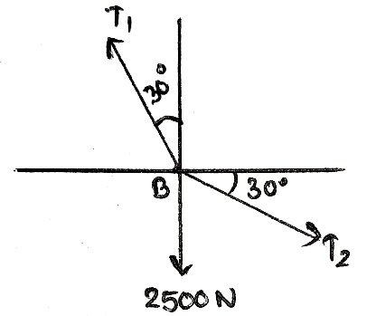 **Solution:**

- (i)

- (ii)

On solving equations (i) and (ii), we get,

T1 = 4330N

And, T2 = 2500N

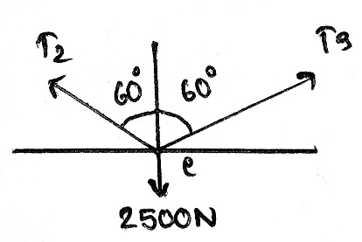

Therefore, T1=4330N, T2=T3=2500N

**ii) Ans) [Moment of Force]** Option b.

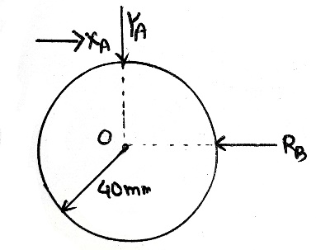 **Solution:**

- (i)

- (ii)

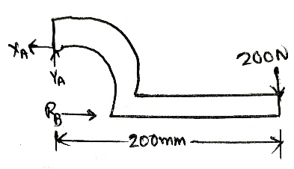 (from i)

Therefore, Forces exerted on cylinder at points A and B are 1020N and 1000N, respectively.

**iii) Ans) [Lami’s Theorem]** Option c.

**Solution:**

Using Lami’s theorem,

So,

And,

Therefore, F=140N and α=120⁰.

**iv) Ans) [Belt Friction]** Option b.

**Solution:**

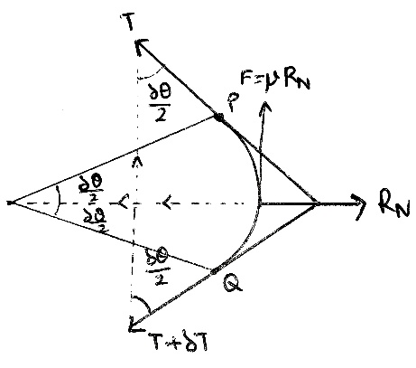For the belt drive,

For small angle , , so,

Also, we have,

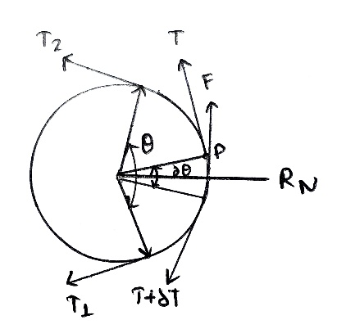 Equating the values of RN, we get,

Integrating between the limits T2 and T1 and from 0 to θ,

we have,

is the required ratio

**v) Ans) [Plane Truss]** Option b.

**Solution:**

Deficient truss is the truss consisting of 8 joints, 10 members and 4 reaction components.

**vi) Ans) [Kinematics of Particles]** Option d.

**Solution:**

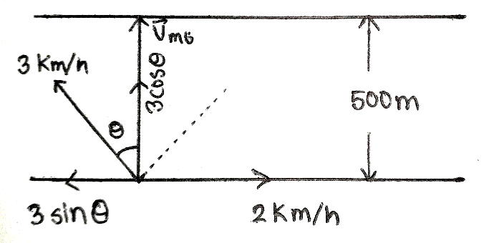Given,

We have,

So,

**vii) Ans) [Projectile Motion]** Option a.

**Solution:**

Given, v = 20 m/s

α = 40⁰

Minimum velocity in a projectile motion is obtained at the top.

Vmin = u cos α = 20 cos40⁰ = 15.32 m/s

**viii) Ans) [Kinetics of Rotational Motion]** Option b.

**Solution:**

The acceleration of a particle at any instant moving along a circular path in a direction normal to the tangent at that instant and directed towards the center of the circular path is known as normal component of the acceleration or normal acceleration. It is also called radial or centripetal acceleration.

**ix) Ans) [Kinematics of Plane Motion]** Option b.

**Solution:**

We know,

Here, d = 60 miles

And, t = (4 pm – 2 pm = 2 hours)

Therefore,

**x) Ans) [Principle of Impulse and Momentum]** Option b.

**Solution:**

We know, momentum = mass x velocity.

Given, both the objects have same momentum, i.e., momentum is constant.

Hence,

i.e., lighter the object, more the velocity. So, the lighter object will have greater velocity

**Group III**

**4.**

**i) Solution) [Plane Truss- Method of Sections]**

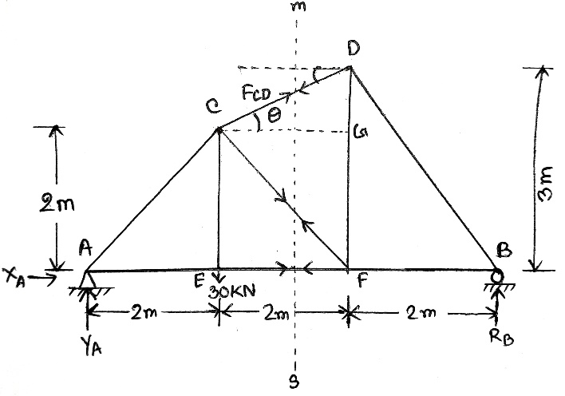 :

In ΔCGD,

To find axial force FCD,

To find axial forces F­CF and FEF,

-(i)

From equation (i),

Therefore, Forces acting in members CD, EF and CF are 7.45KN (C), 20KN (T) and 18.85KN, respectively.

**ii) Solution) [Plane Truss- Method of Joints]**

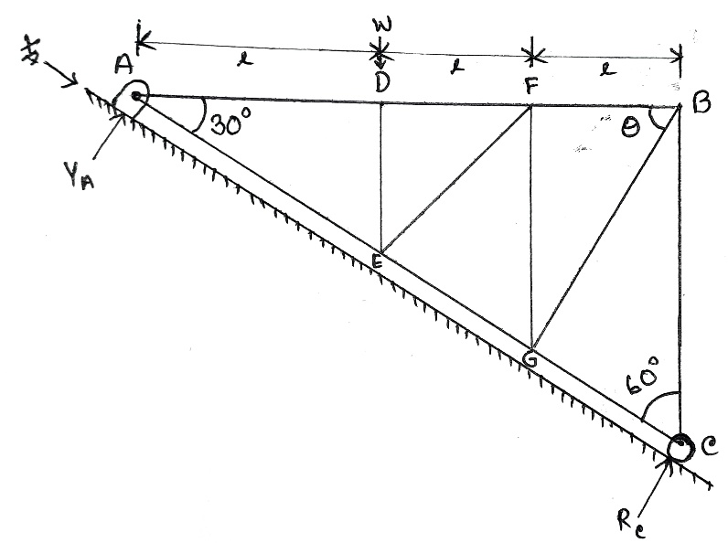∑MA = 0,

Rc  – W (l) =0

Or, Rc  =W

∴ Rc =

In ∆ABC,

Cos 30°=

Or, AC=

**Joint C**

∑Fy = 0,

–FGC –FBC cos 60° = 0 (i)

∑Fy = 0,

Rc + FBC sin 60° = 0

Or, FBC =

Or, FBC = ×

Or, FBC =

∴ FBC = (Compressive)

Equation becomes,

FGC= ×

∴ FGC= (Tensile)

In ∆AFG,

tan30° =

or, =

∴ FG =

In ∆BFG,

tanθ =

or, tanθ = ×

or, tan =

θ = tan-1

∴ θ = 49.1°

**Joint B:**

∑Fy = 0,

–FBF – FBG cosθ = 0 (ii)

∑Fy = 0,

–FBC – FBG sinθ = 0

Or, = FBG sinθ

Or, FBG =

∴ FBG = 0.44 W (tensile)

Equation (ii) becomes,

–FBF = FBG cosθ

Or, –FBF = 0.44 W × cos(49.1°)

Or, FBF = -(0.288)W

∴ FBF = 0.288 W (compressive)

**Joint G:**

∑Fy = 0,

FGC–FEG – FBG cos(79.1°) – FGF cos(60°)= 0

Or, + 0.44 W×cos(79.1°)= FEG + FGF cos(60°)

∴ FEG + FGF cos(60°) = 0.2498 W (iii)

∑Fy = 0,

FBG sin(79.1°) + FGF sin(60°)= 0

Or, = – FGF

Or, FGF = – 0.4989 W

Or, FGF = – 0.5 W

∴ FBG = 0.5 W (Compressive)

Equitation (iii) becomes,

FEG = FBG cosθ

Or, FEG = 0.2498 W + 0.5 × cos(60°)

∴ FEG = 0.5 W (compressive)

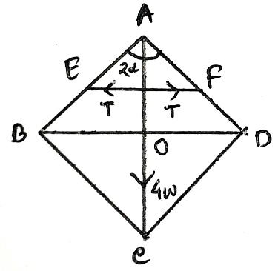 **iii) Solution) [Virtual Work]**

We know,

Total weight 4W acts on O.

Let, T be the thrust in the rod EF. Joining midpoint of AB and AD.

Here,

Point of suspension A is fixed.

Let, length of rod is 2a.

So, ∠ BAO= α

In ∆ABO,

= cosα

Or, = cosα

∴ AO= 2a cosα (i)

Now for EF,

As EF = 2EK

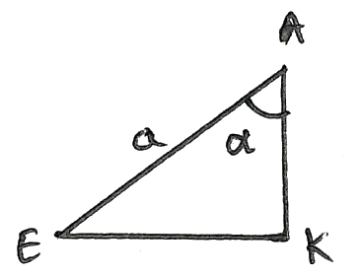In ∆AEK,

EF= 2EK

∵ = sinα

Or, EK= sinα

∴ EF= 2asinα = l (say)

Now, give the system a small virtual displacement such that α becomes α+𝛿α and l becomes l+𝛿l. Then the equation of the virtual work is-

4W. (AO) + T. 𝛿l = 0

Or, ∆W (2a cosα) + T𝛿 (2a sinα)= 0

Or, 8Wa sinα 𝛿 α + T 2a cosα. 𝛿α= 0

∴ T= 4W. tanα [∵𝛿α≠0]

**iv) Solution) [Friction]**

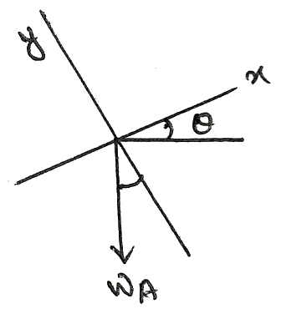Given, µA=0.3, µB=0.2

From FBD of Block A,

- (i)

- (ii)

From equations (i) and (ii), and putting known values, we get,

75 cosθ – 250 sinθ = R - (iii)

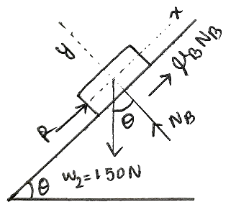 From FBD of Block B,

- (iv)

- (v)

From equations (iv) and (v), and putting known values, we get,

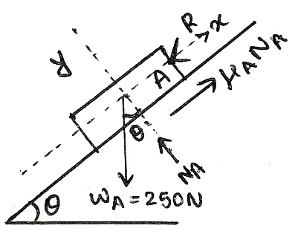 - (vi)

From equations (iii) and (vi),

Therefore, 14.7⁰ is the maximum angle that can be reached before bodies slip down the incline.

**v) Solution) [Ladder Friction]**

Given, ,

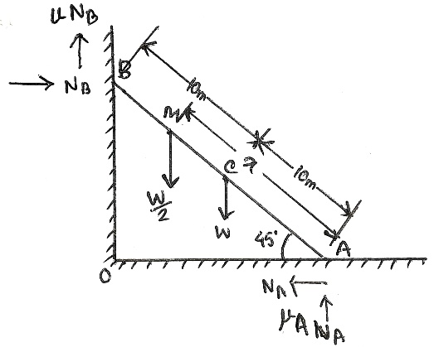

- (i)

From (i),

- (ii)

- (iii)

In ΔAOB, AB=20m,

In ΔAC1C,

In ΔAM1M,

From equation (ii) and (iii), putting values we obtained, we get,

**vi) Solution) [Projectile Motion]**

Known Values, yo = 100m; vo = 30m/s;

θ = 20⁰; xo = 0m

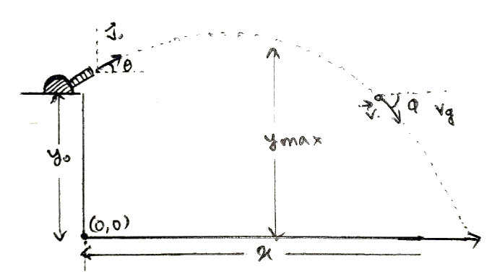 (a) To find range,

At impact, y=0m

We know,

Using the quadratic formula,

This gives,

either, t = -3.59 (time cannot be in negative, so no valid)

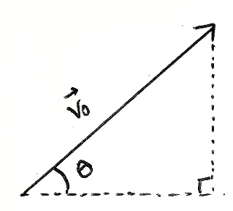 or, t = 5.68 s

Again,

Therefore, the horizontal range covered by the projectile is 160.1m.

(b) To find peak height,

At peak height, vg = 0m/s

We know,

Also,

Therefore, the peak height attained by the projectile is 105.4m.

**vii) Solution) [Direct and Oblique Collision]**

Firstly, we know,

- (i)

Also,

- (ii)

Multiplying (ii) by 4 and then adding (i), we get,

Checking Condition I by putting the obtained values for and ,

Checking Condition II, by putting the obtained values for and ,

Checking Condition III, by putting the obtained values for and ,

**viii) Solution) [Projectile Motion]**

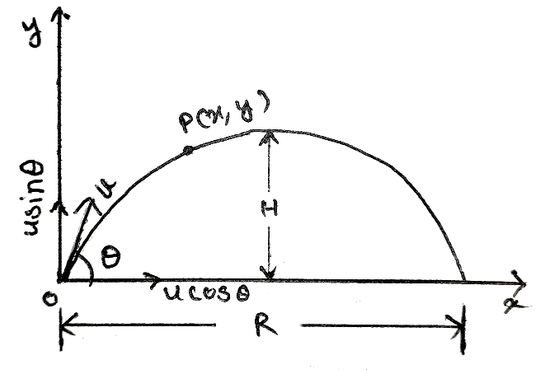We have,

- (i)

- (ii)

Replacing value of t from (i) in (ii),

- (iii)

(a) To find time of flight:

For this, putting y = 0 in equation (ii), we get,

Time of flight,

(b) To find the maximum vertical distance (height) covered,

(c) To find the maximum horizontal distance covered,

**ix) Solution) [Kinetics of Particles]**

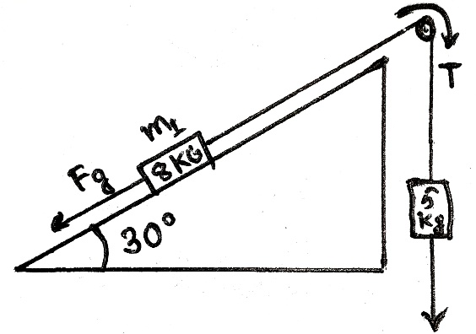We know,

Fg = mg sinθ

So, Fg = 8 (9.8) sin 30⁰ = 39.2N

(a) Now,

So,

(b) Also,

And,

Therefore, the tension in the rope is 45.23N.

(c)

To find a hanging mass that will balance the system,

We have,

Therefore, a hanging mass of 4 kg will cause the system to remain at rest.

**x) Solution) [Kinematics of Plane Motion]**

Firstly for car P,

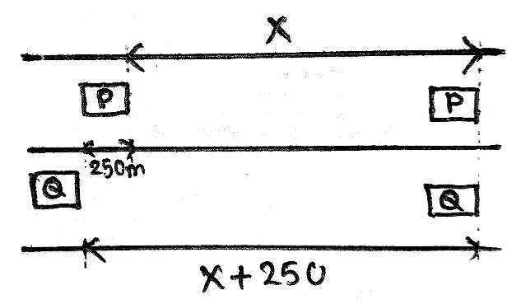 Known values,

u = 16.67 m/s

a = -2.5 m/s2 (for deceleration)

Let, s = x.

Using,

- (i)

Now, for car Q,

Known values,

u = 16.67 m/s

s = x + 250

a = 2 m/s2

Using,

- (ii)

Equating (i) and (ii), we get,

t = 10.541 s

Substituting the value of t in (i), we get,

x = 36.827 m

Therefore, The car Q will overtake car P at the distance of 36.827m from the instant, which is equivalent to 10.541 seconds.